FSD – Capsule Program – Final Assignment

Padmashrividhya rajan

2019

**FSD - Capsule Program – Final Module**

*Candidate: Padmashrividhya Rajan*

1. Code Repository:

**GIT**

* Service
  + [**https://github.com/Vidhya2k/ProjectManagerService**](https://github.com/Vidhya2k/TaskManagerService)
* UI
  + [**https://github.com/Vidhya2k/ProjectManagerUI**](https://github.com/Vidhya2k/ProjectManagerUI)

**Local Machine**

C:\Work\ProjectManager

1. Database
   1. Server Name : **DOTNET**
   2. DataBase Name : **ReportServer**
   3. Table Names : **TASK, PROJECT AND USERS**
2. Unit Testing
   1. It’s part of the ProjectManagerService Solution (NUnit)
3. Performance Testing
   1. It’s part of the ProjectManagerService Solution (NBench)
4. OpenCover
   1. Partially completed. Setup is available in C:\Work\TaskManager
5. IIS URL
   1. http://localhost/ProjectManagerService
6. Jenkins
   1. http://localhost:8080/ProjectManagerService

**Steps to run applications in remote Machine**

1. **Task Manager**
   1. Run Project Manager Service
      1. Navigate to C:\work\ProjectManager\ProjectManagerService
      2. Launch ProjectManagerService.sln
      3. Run the solution
   2. Run Task Manager UI
      1. Navigate to C:\work\ProjectManager\ProjectManagerUI
      2. Launch ProjectManagerUI.sln
      3. Run the solution
2. **NBench**

* Open Windows PowerShell prompt
* Run the below command:
  + Cd C:\work\ProjectManager\ProjectManagerService\packages\NBench.Runner.1.2.2\tools\net452
  + .\Nbench.Runner.exe C:\work\ProjectManager\ProjectManagerService \BusinessLogicLayer.Test\bin\debug\ BusinessLogicLayer.Test.dll
* Hit Enter and verify the results

**NBench Results**

**Project Manager UI – Screenshots**

1. **Add Project**

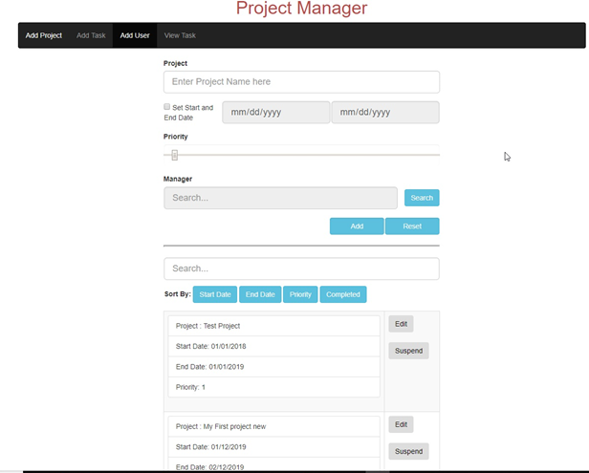

1. **Search Users**

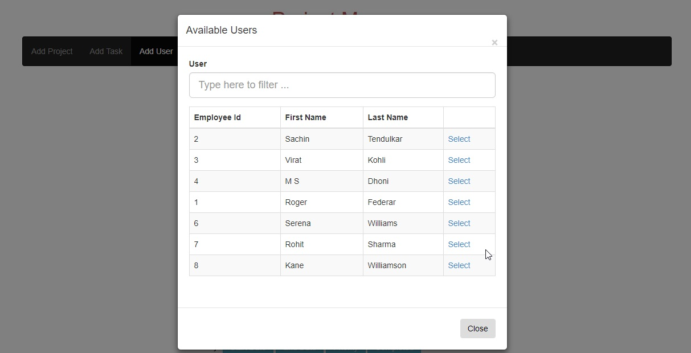

1. **Add Task**

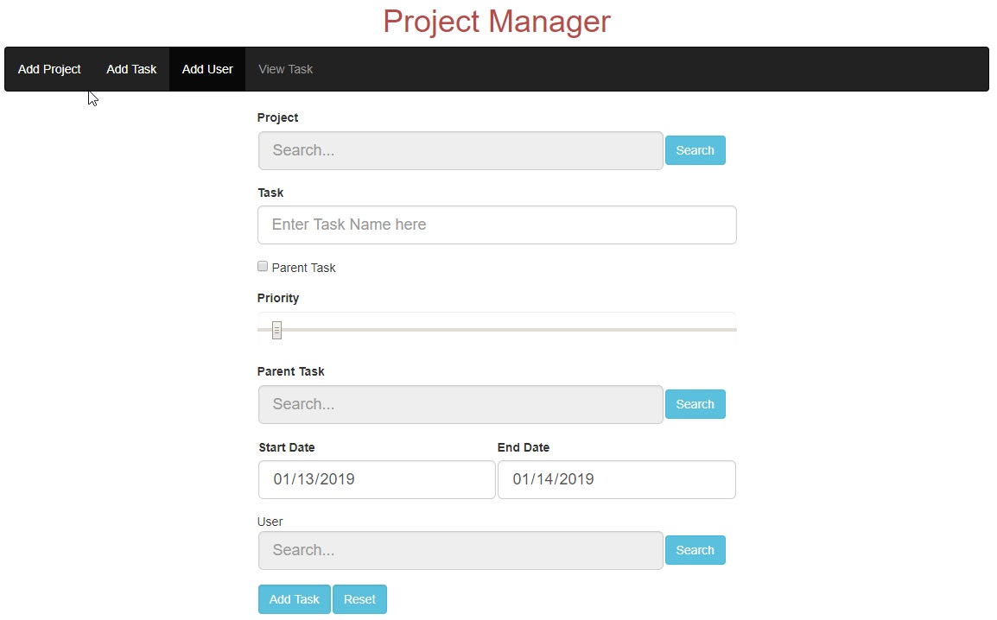

1. **Search Projects**

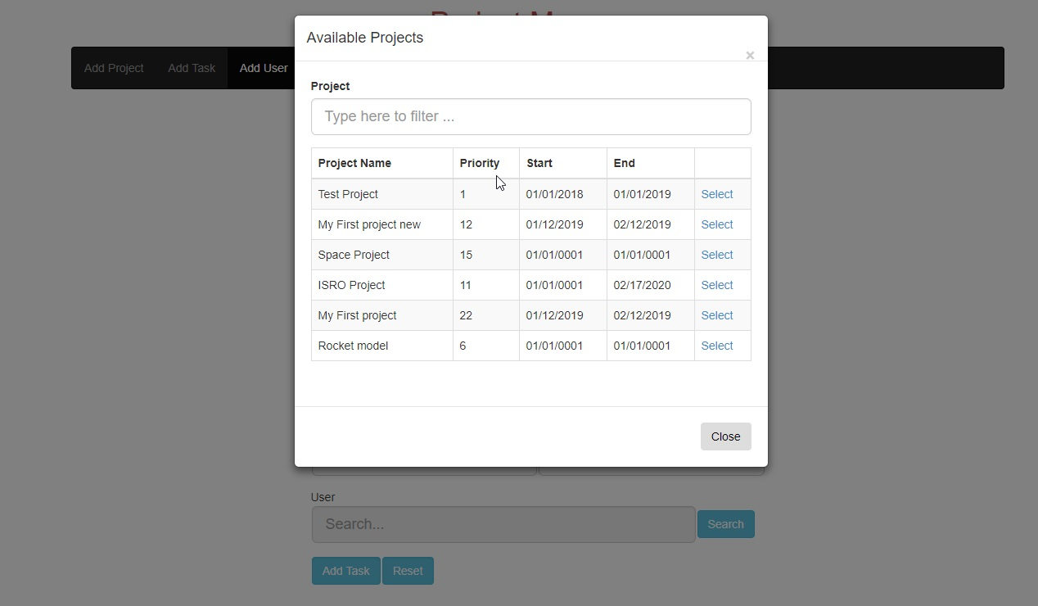

1. **Users Search**

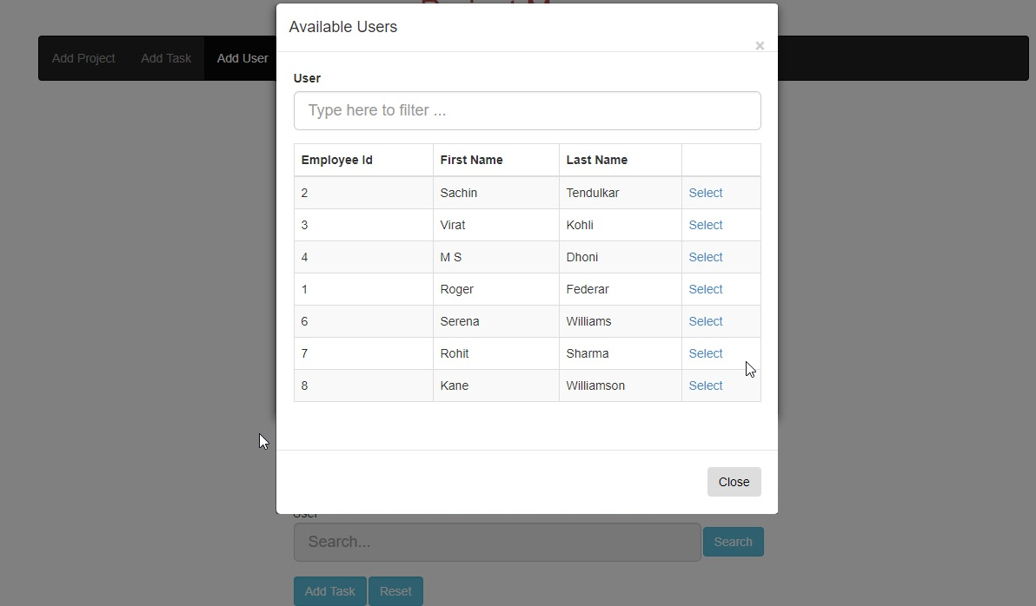

1. Add Users

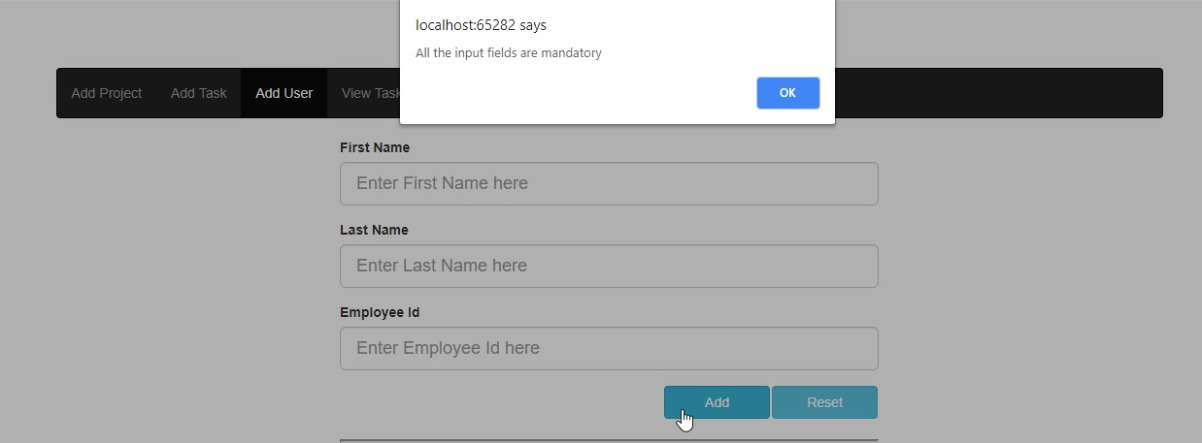

1. **View Tasks**

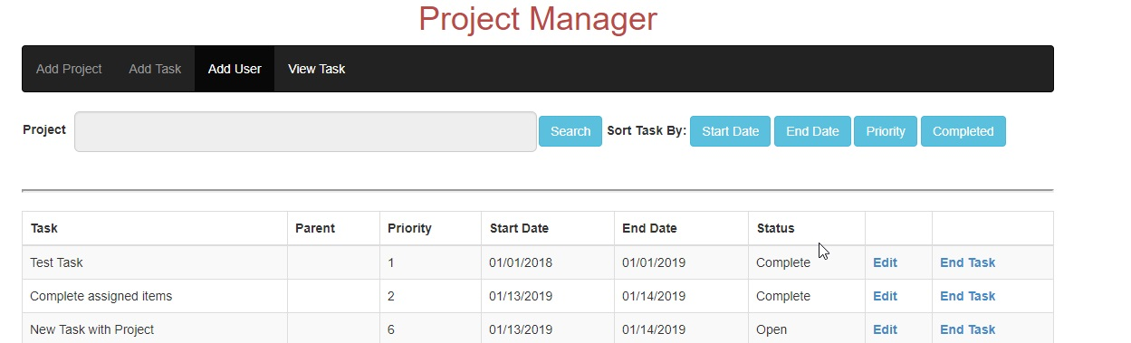

1. **Search Projects**

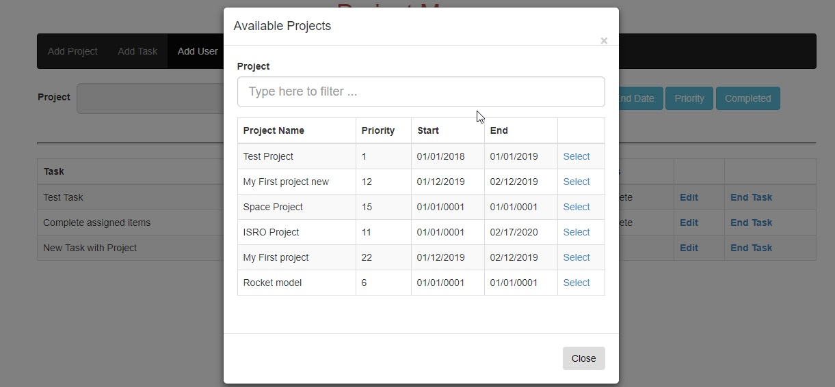

**Continues Integration Results (Jenkins)**

**Known Issues**